**Suggested Supplies for 5th Grade**

**Label only these supplies:**

* 1” Binder
* Plastic Dividers with pockets (8 count) 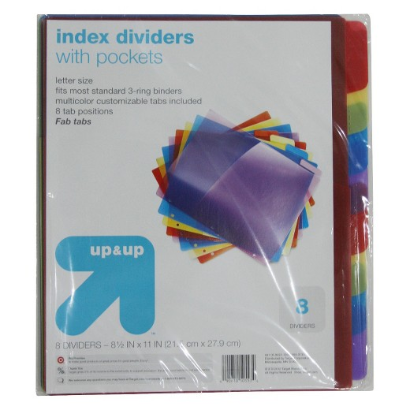
* 1 pair of scissors
* 1 package markers
* Colored pencils

** A pencil caddy will be provided for your student to keep in their desk.

** You may bring your own pencil box.

**Please don’t label the following supplies below:**

* 24 (#2) pencils
* 2 packages dry erase markers (thin)
* 2 glue sticks
* 2 packages **college** ruled filler paper
* 2 boxes of tissue
* 2 packages of pencil top erasers
* 2 packages of Clorox Wipes